# Security Monitoring and Logging using SIEM

1. **If you didn't choose to start Splunk during the installation, start it manually by navigating to ‘C:\Program Files\Splunk\bin’ and running ‘splunk.exe start’.**

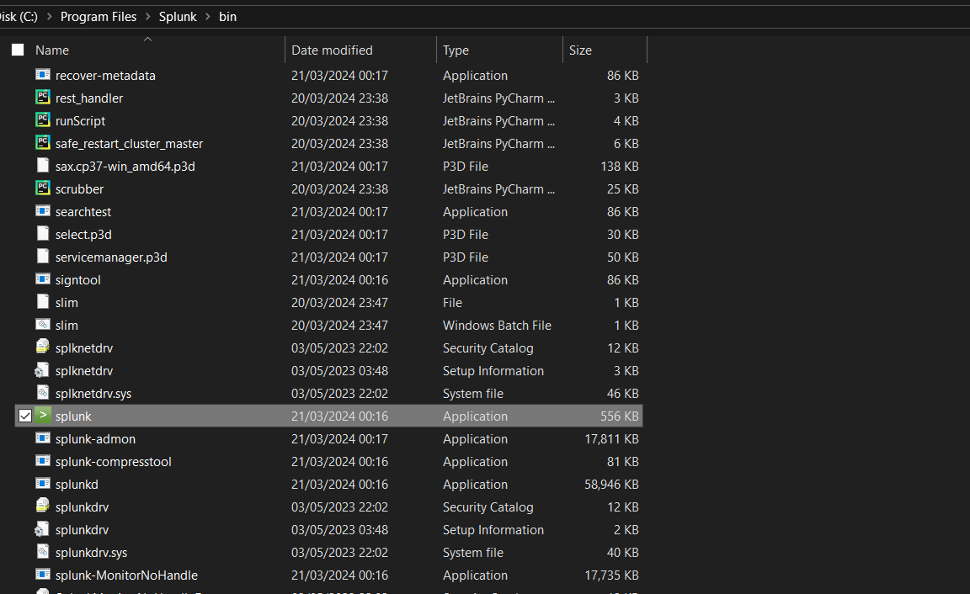

1. **Open Splunk Web:**

Open a web browser and go to ‘http://localhost:8000’.

Log in with the username and password you created during installation.

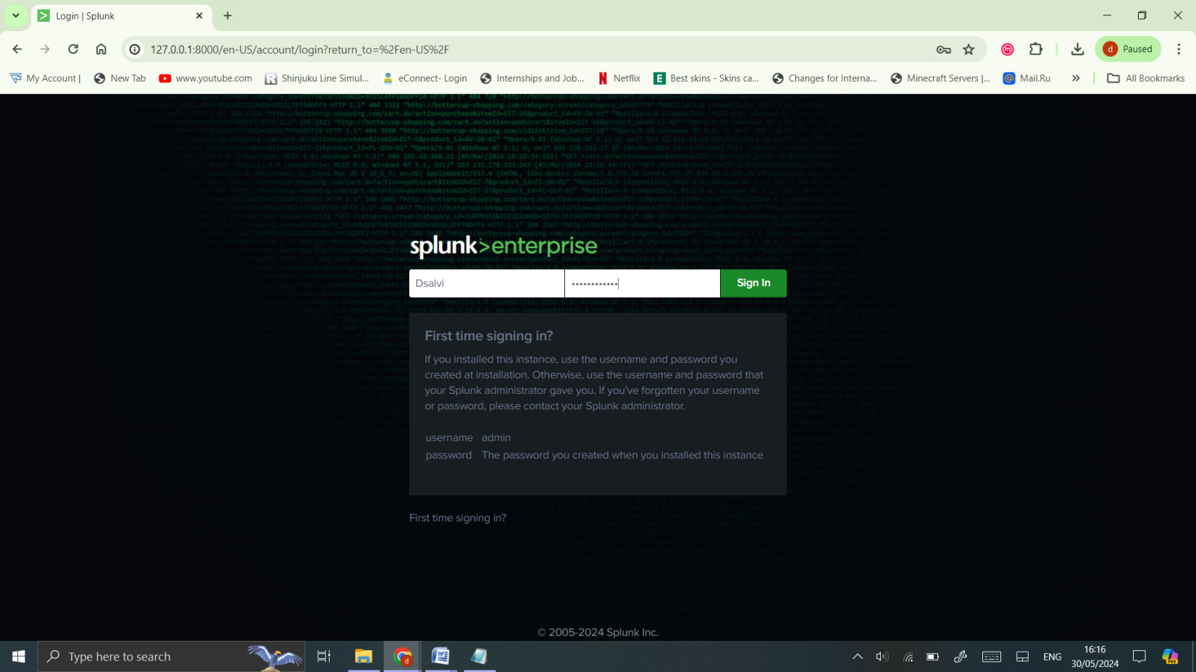

1. **Configure Splunk:**

Follow the initial setup prompts to configure basic settings like time zone and email settings.

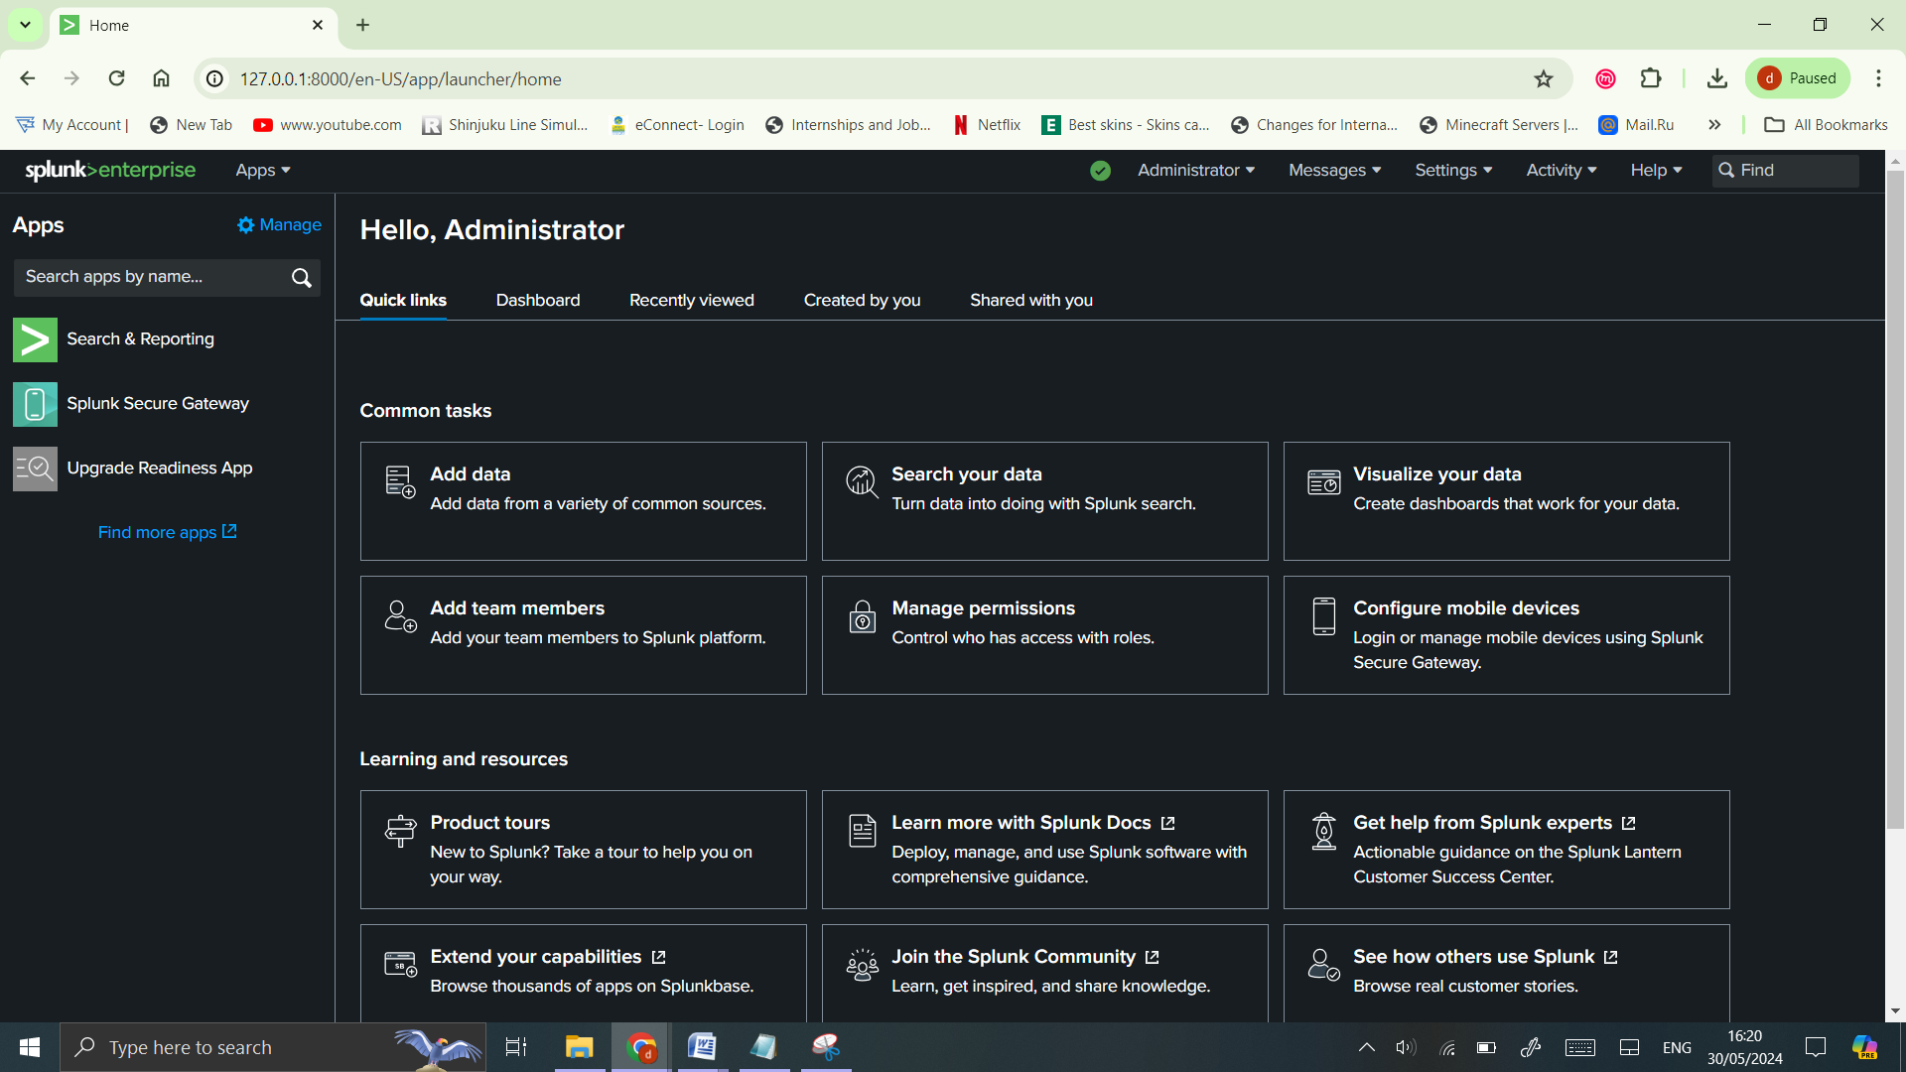

1. **Install Necessary Splunk Apps for SIEM**

In Splunk Web, go to ‘Apps > Manage Apps’.

Click ‘Install app from file’ and upload the downloaded ‘.spl’ files.

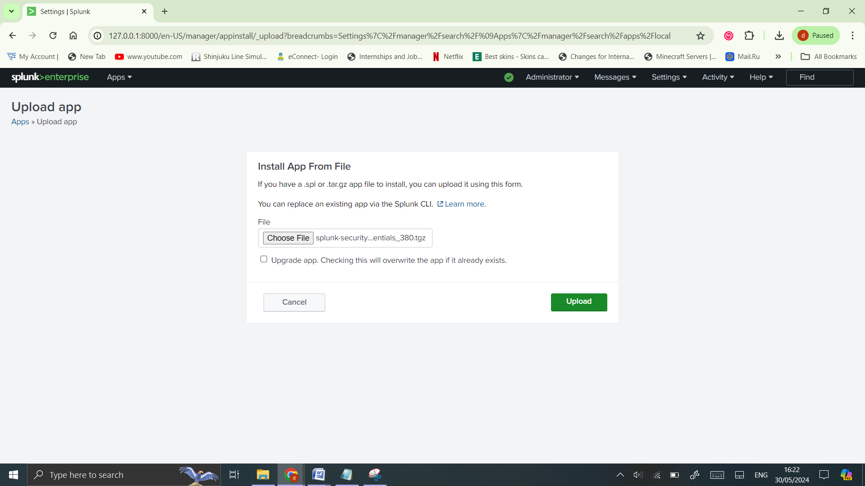

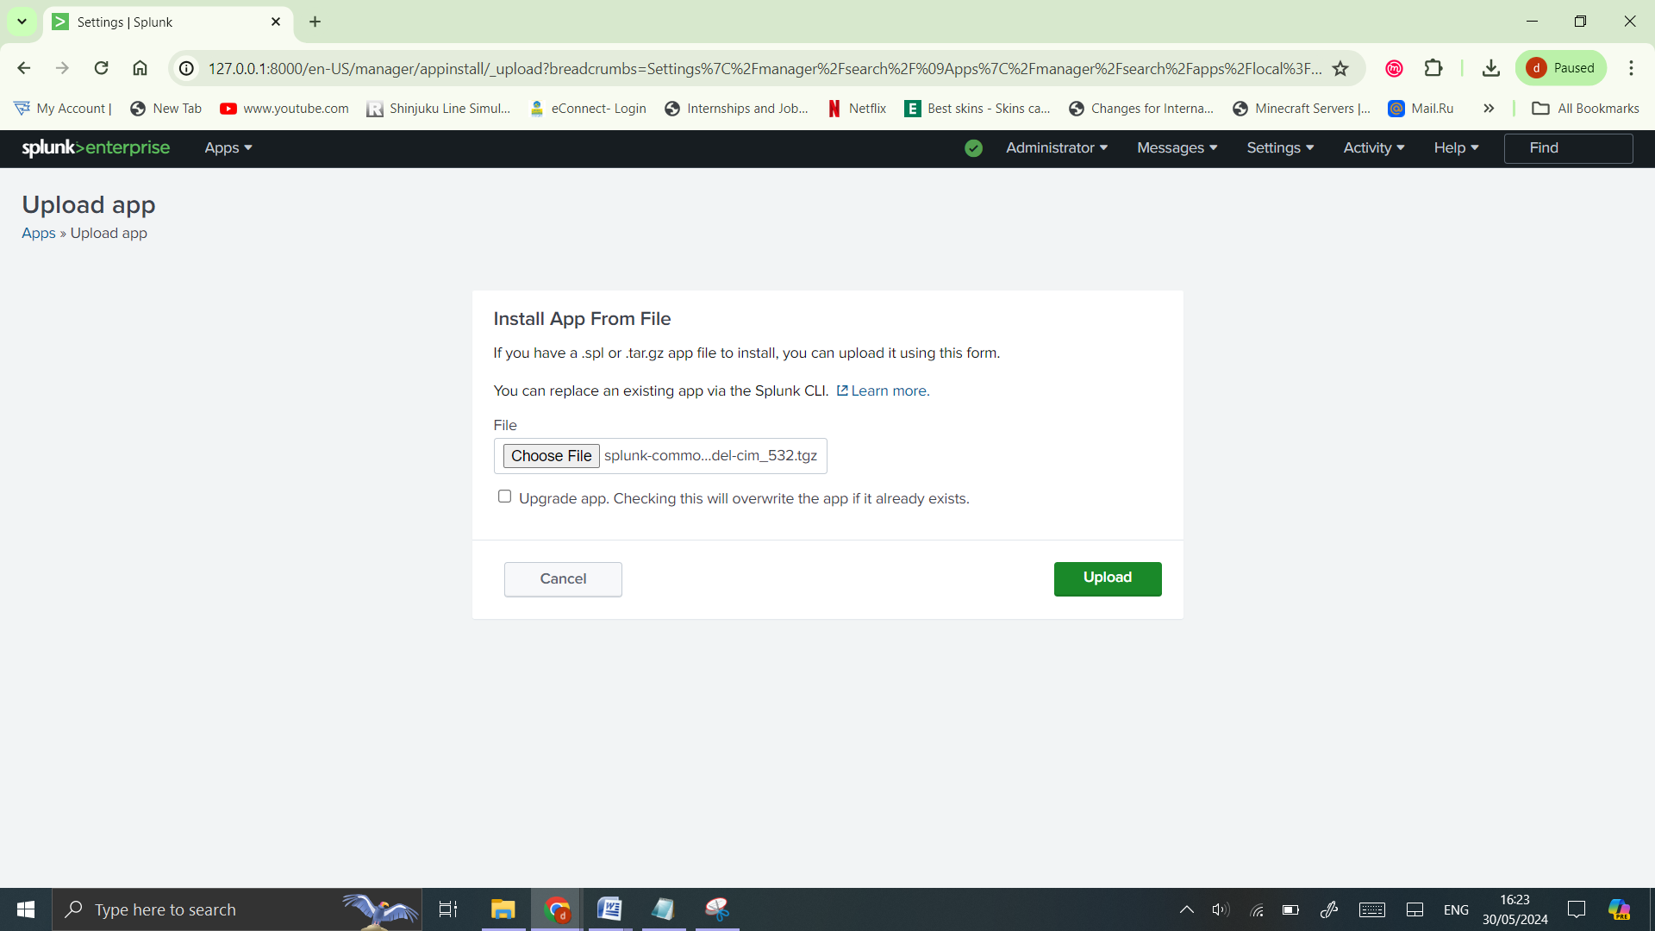

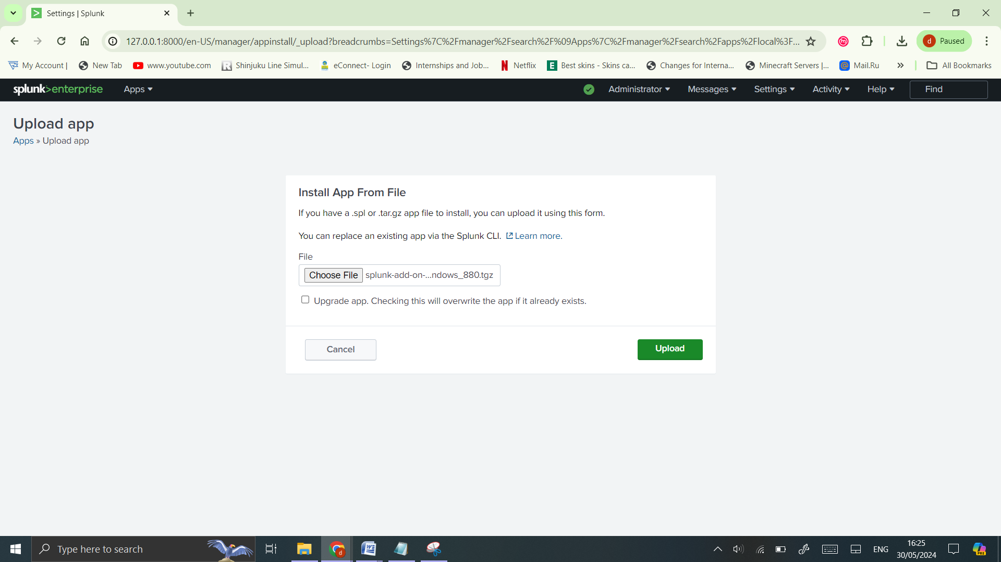

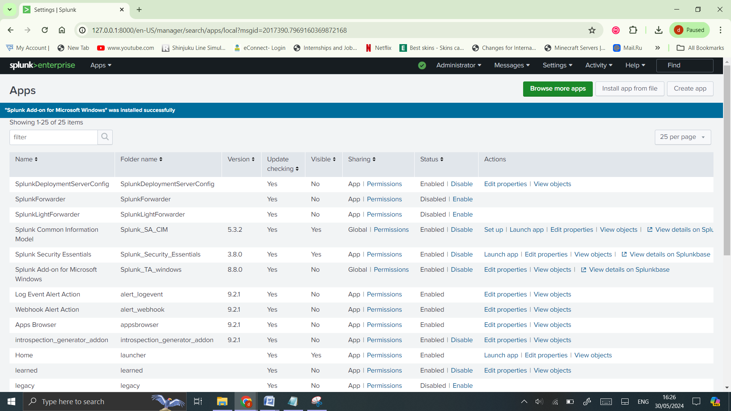

1. **After installing the apps, restart Splunk to apply the changes. Go to ‘Settings > Server controls > Restart Splunk’.**

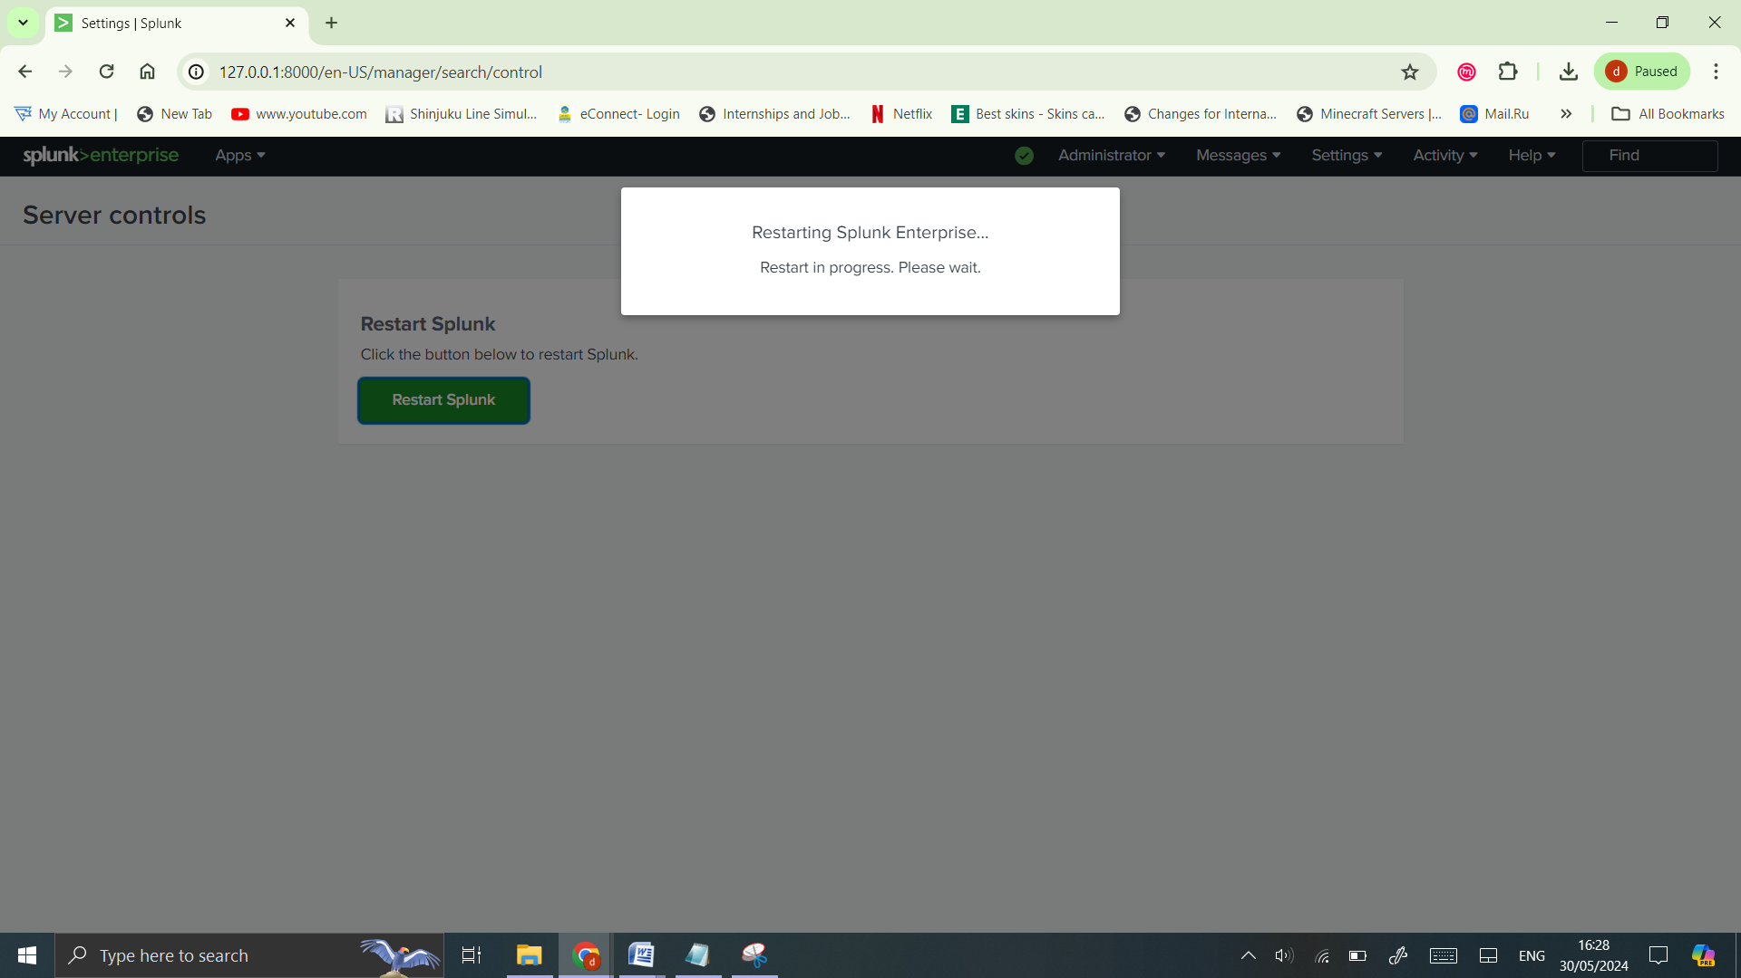

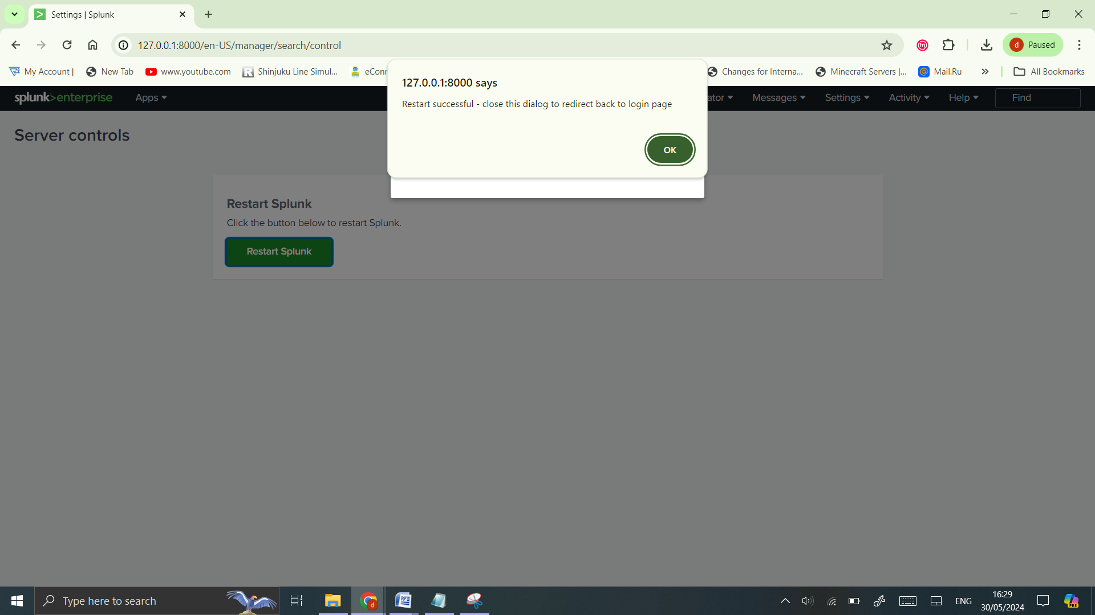

1. **Configure Windows Event Logs:**

In Splunk Web, go to ‘Settings > Data Inputs > Local Event Log Collection’.

Add the event logs you want to monitor (e.g., Application, System, Security).

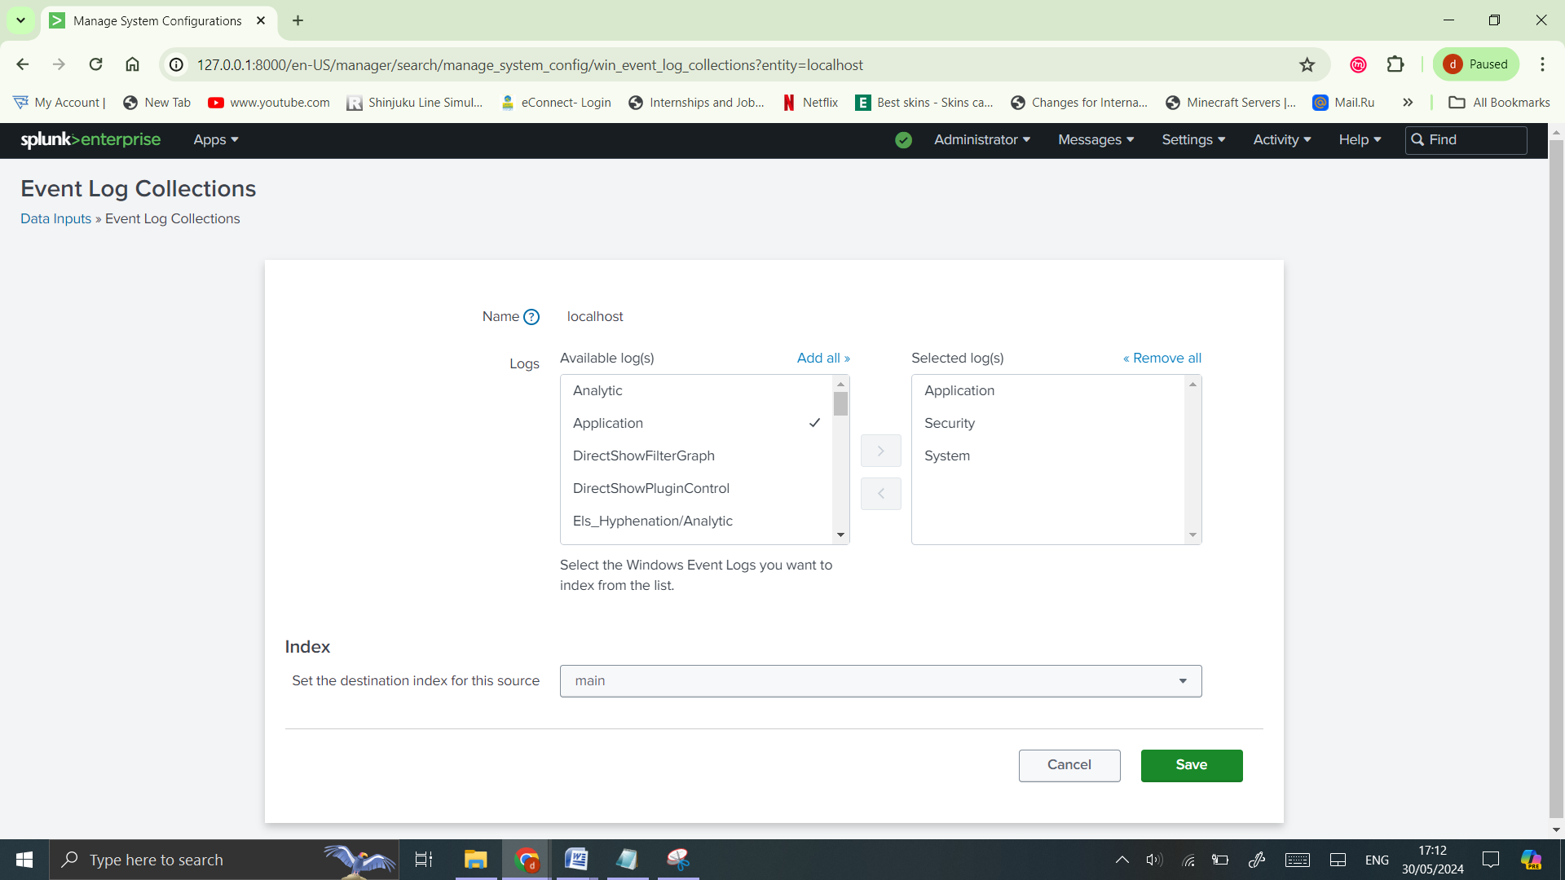

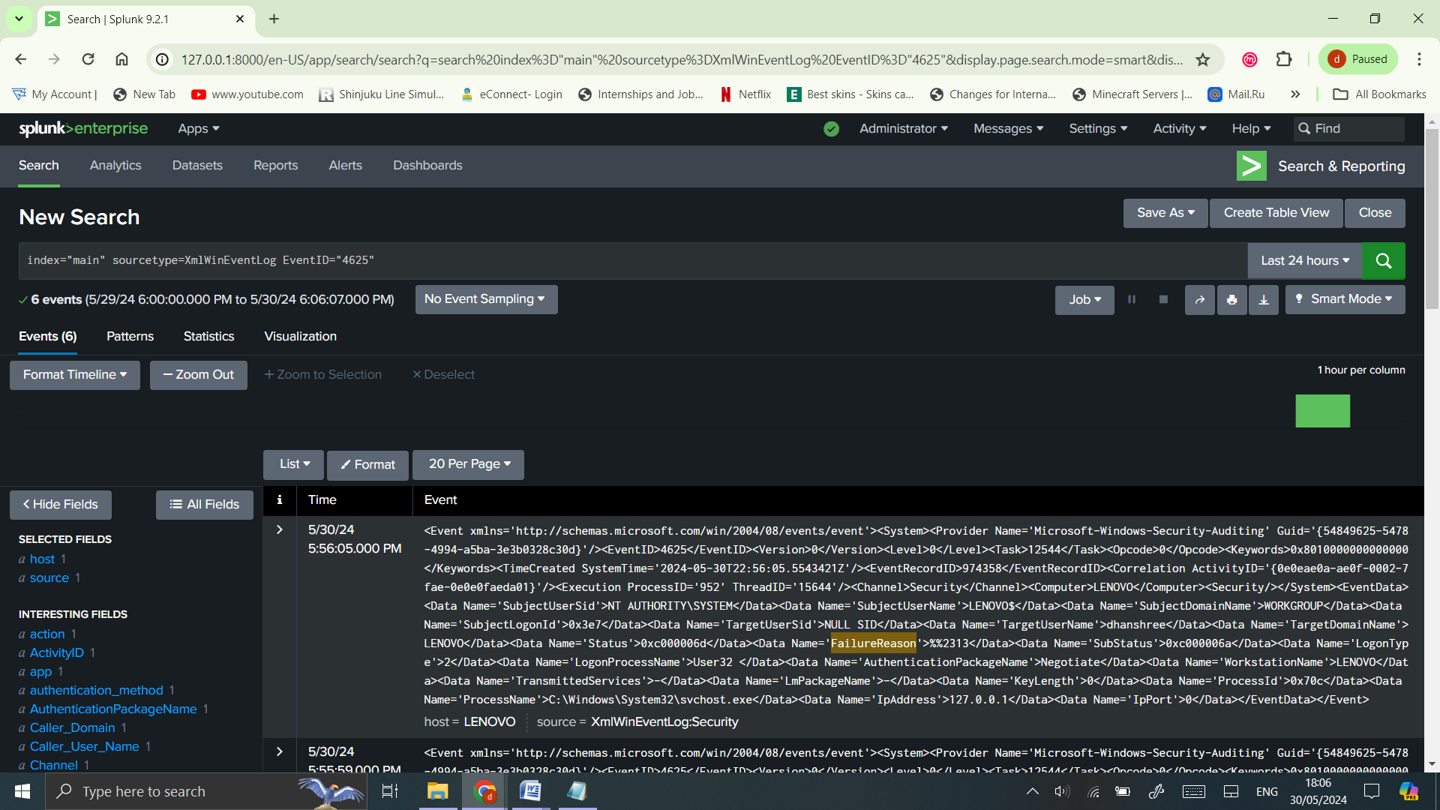

1. **Configure Windows Performance Monitoring:**

Go to ‘Settings > Data Inputs> Local Performance Monitoring’.

Add the performance counters you want to monitor (e.g., Processor, Memory, Network).

**Processor**

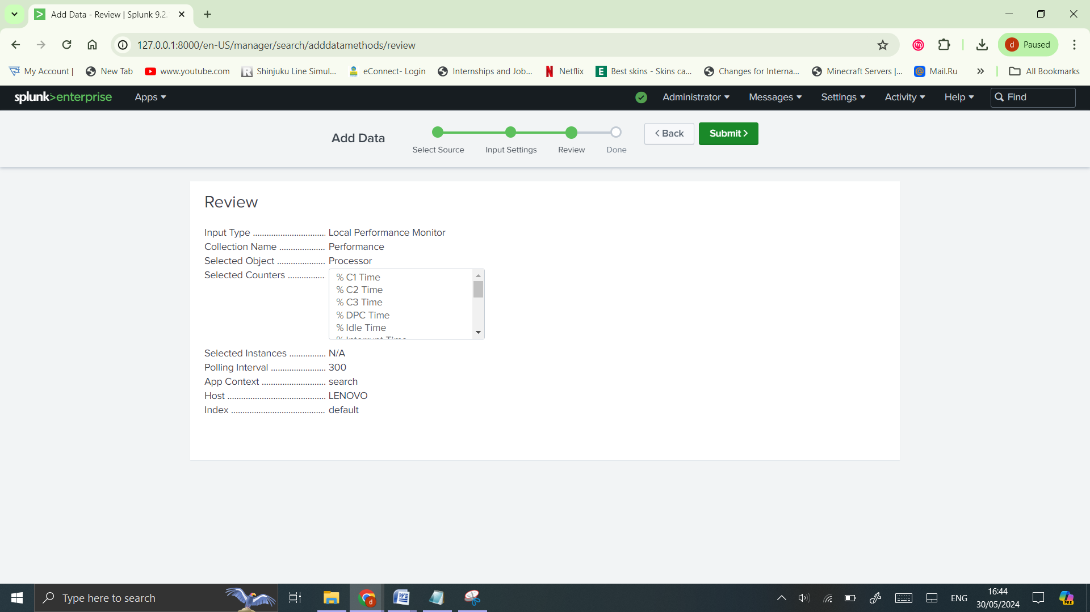

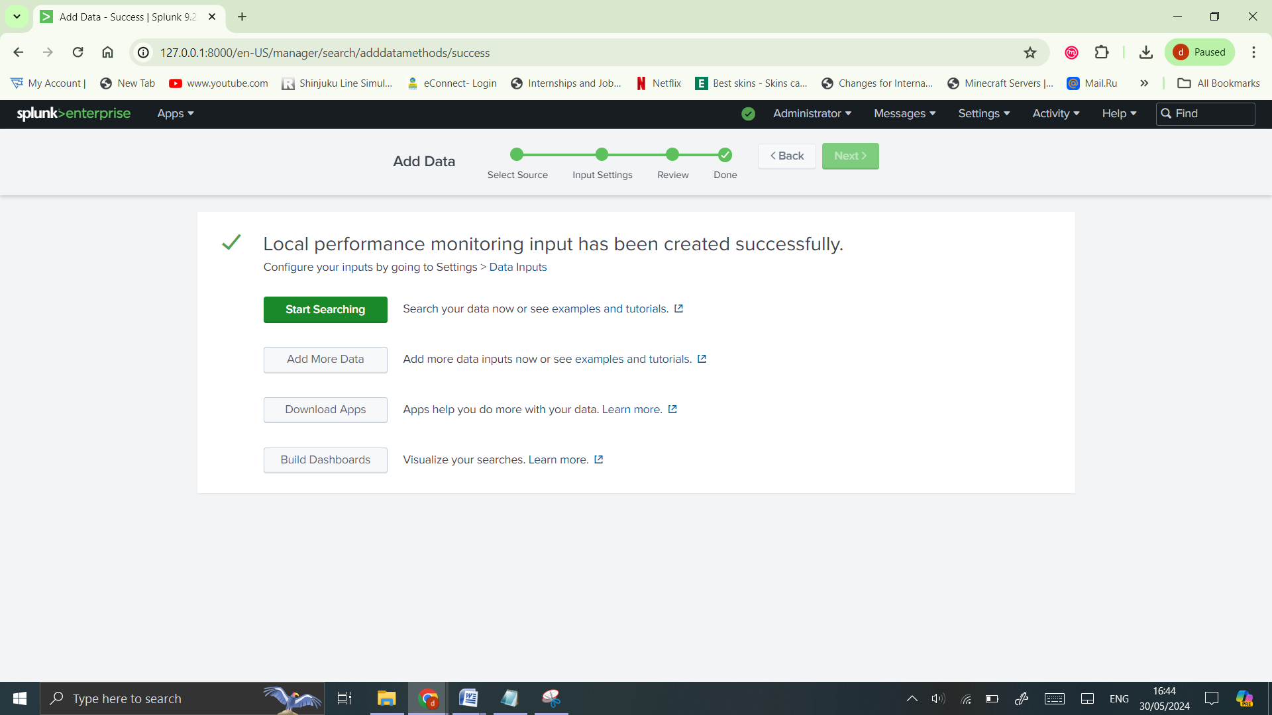

**Memory**

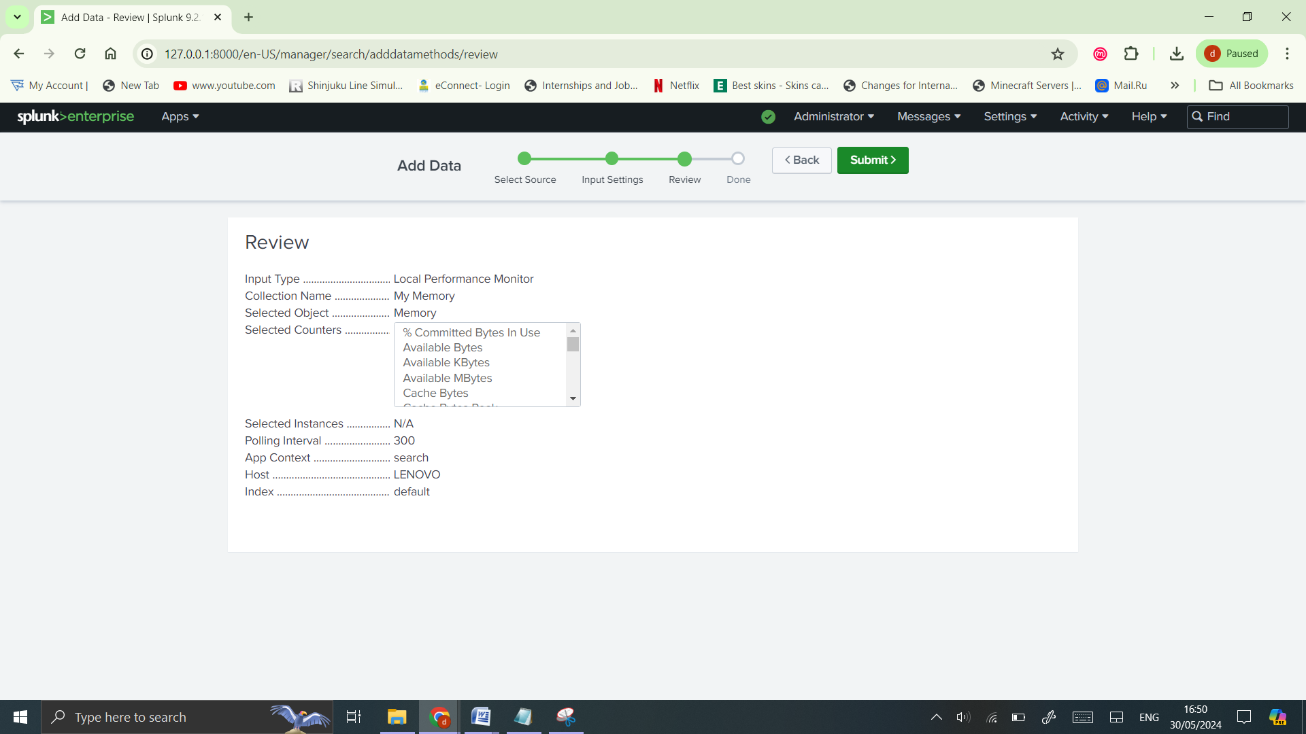

**Network**

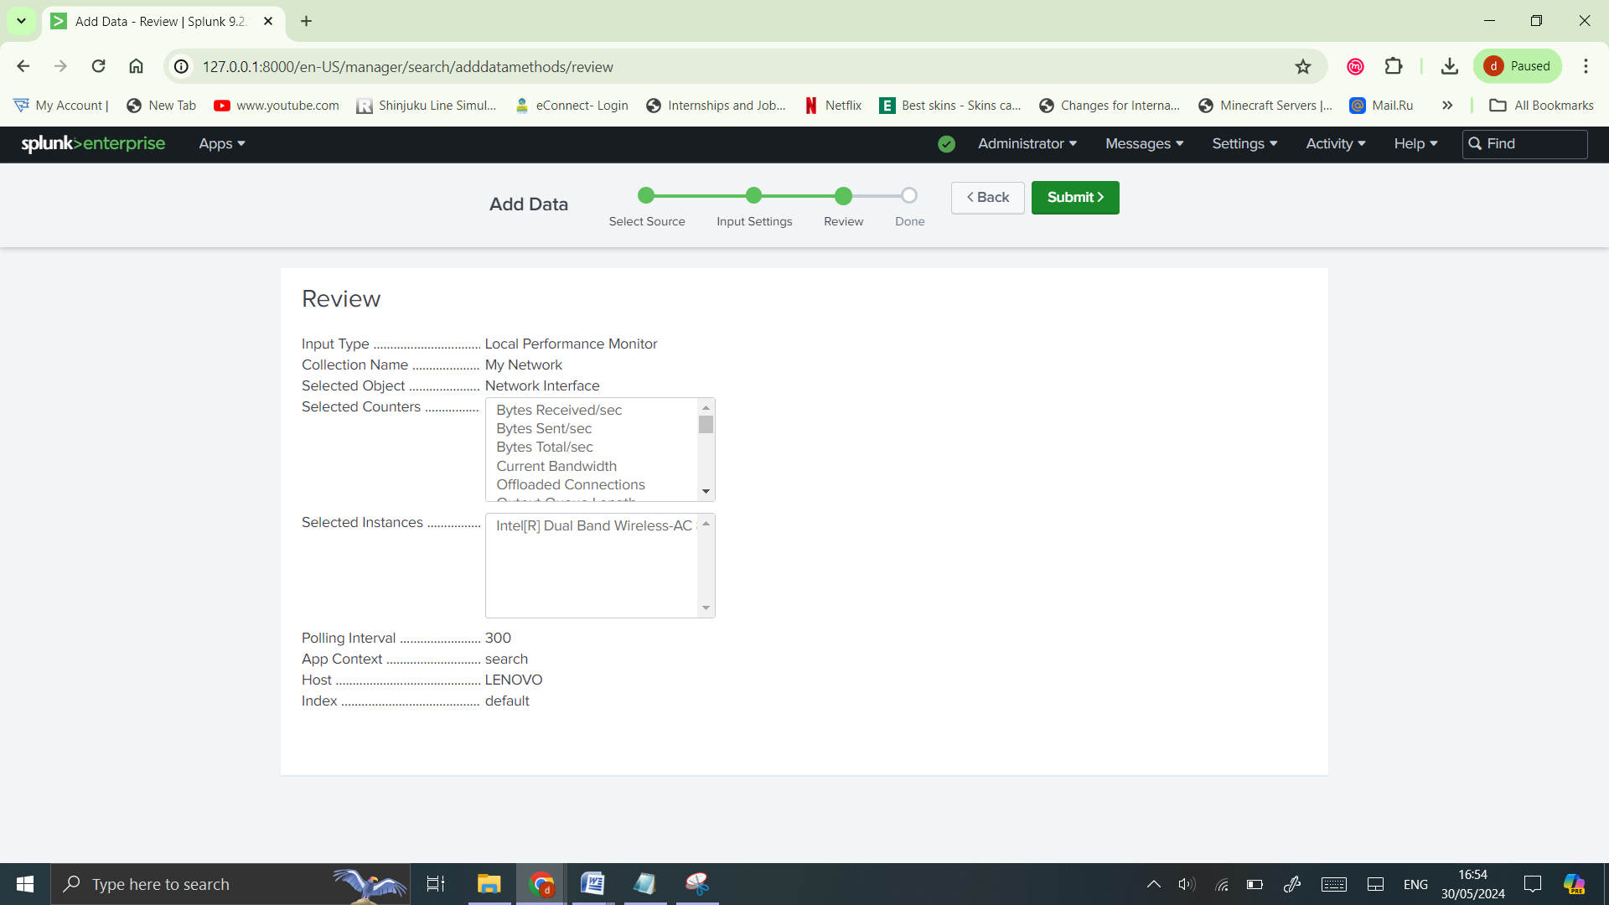

1. **Verify Data Ingestion**

**Search for Data:**

In Splunk Web, go to ‘Search & Reporting’.

Use the search bar to verify data is being indexed: index=main sourcetype=WinEventLog

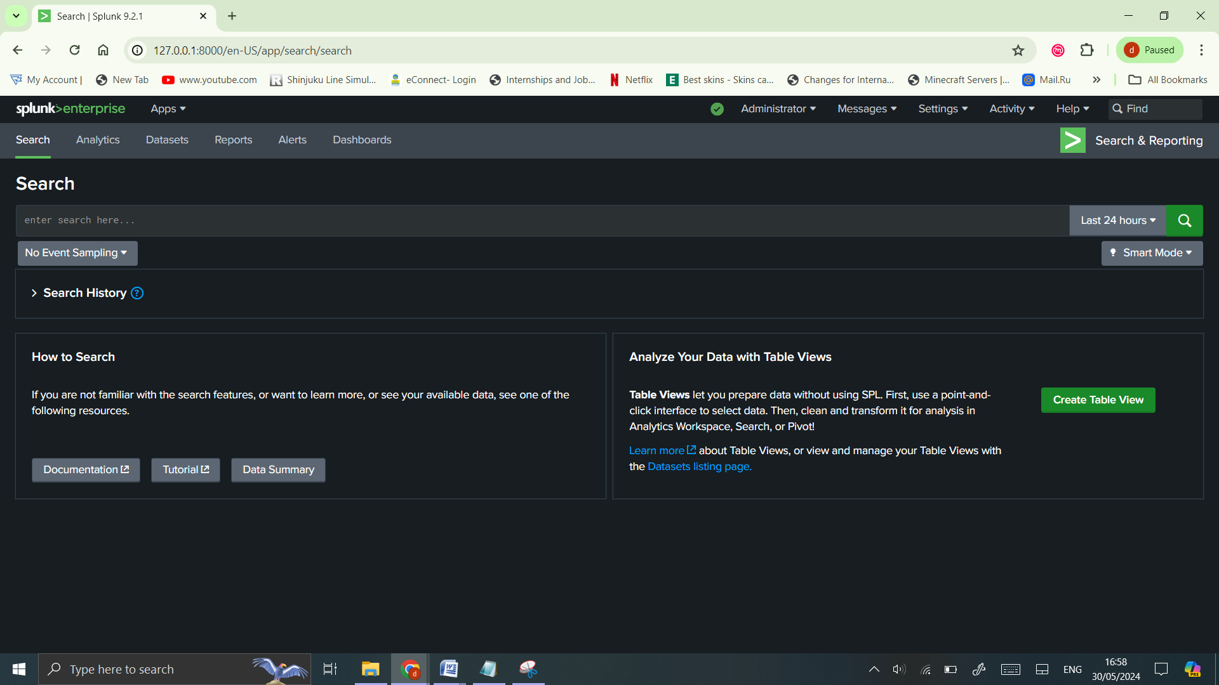

1. **Check for Errors:**

Ensure there are no errors in data collection by checking ‘Settings > Monitoring Console >Indexing > Indexing Performance’.

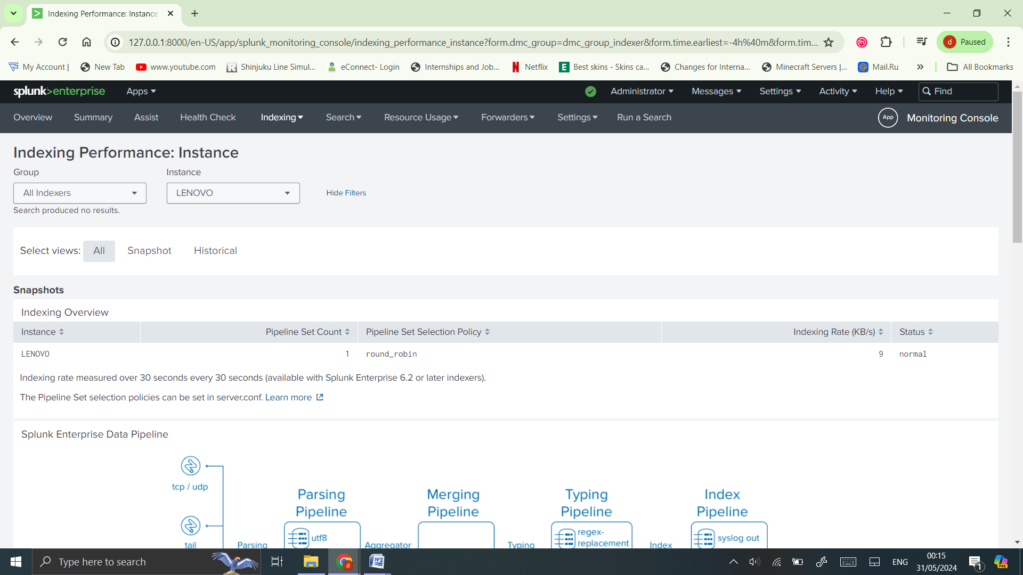

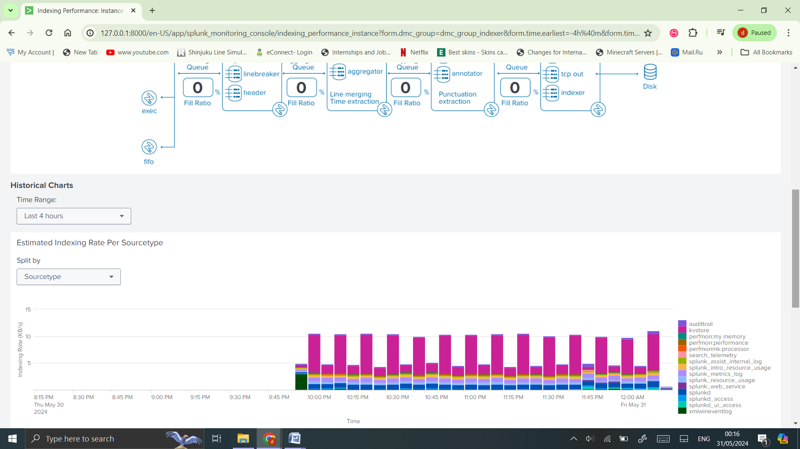

1. **Create Alerts & Generate Report:**
   * Go to Settings > Searches, Reports, and Alerts.
   * Create new alerts based on the security events you want to monitor (e.g., failed logins).
   * Go to Apps > Search & Reporting > Run the below Query > Click on ‘Save As’ > Report.

**Query:** index="main" sourcetype=XmlWinEventLog source="XmlWinEventLog:Security" EventID=4625

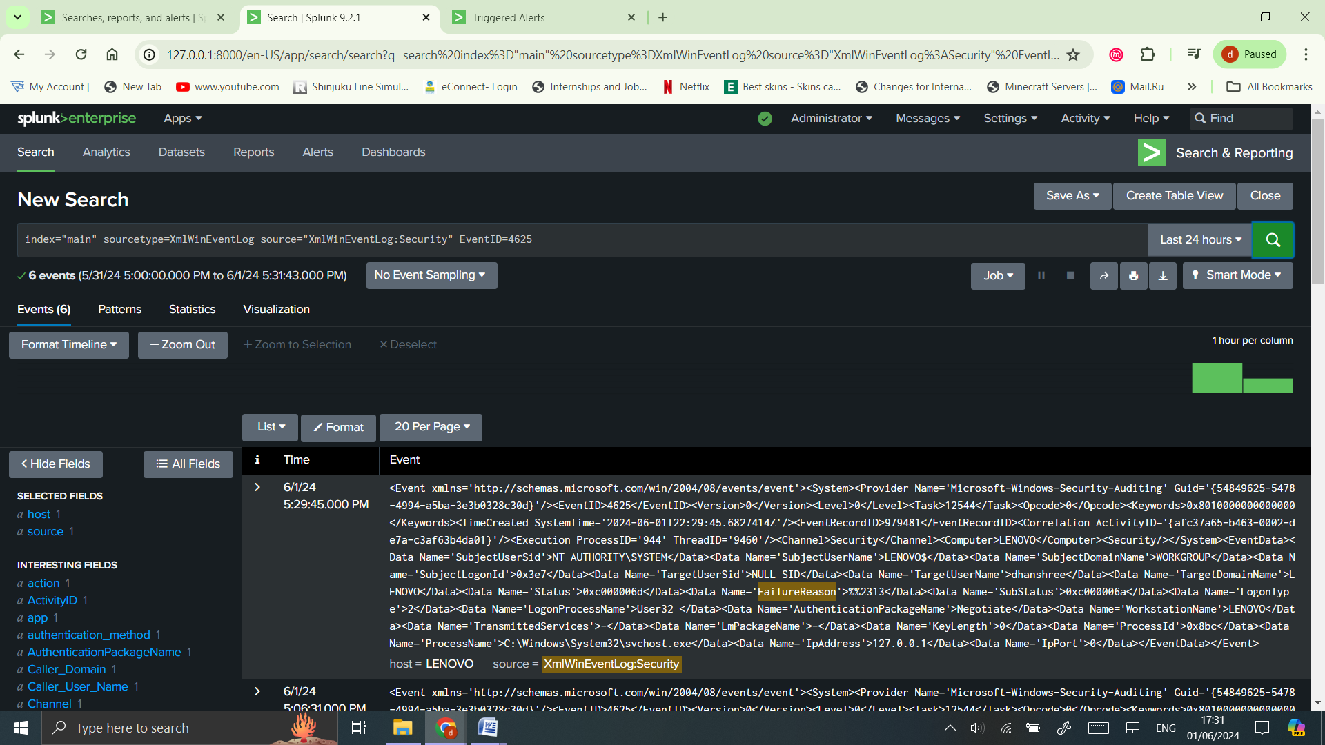

**Go to Activity > Triggered Alerts**

**Generated Report for Event ID 4625**

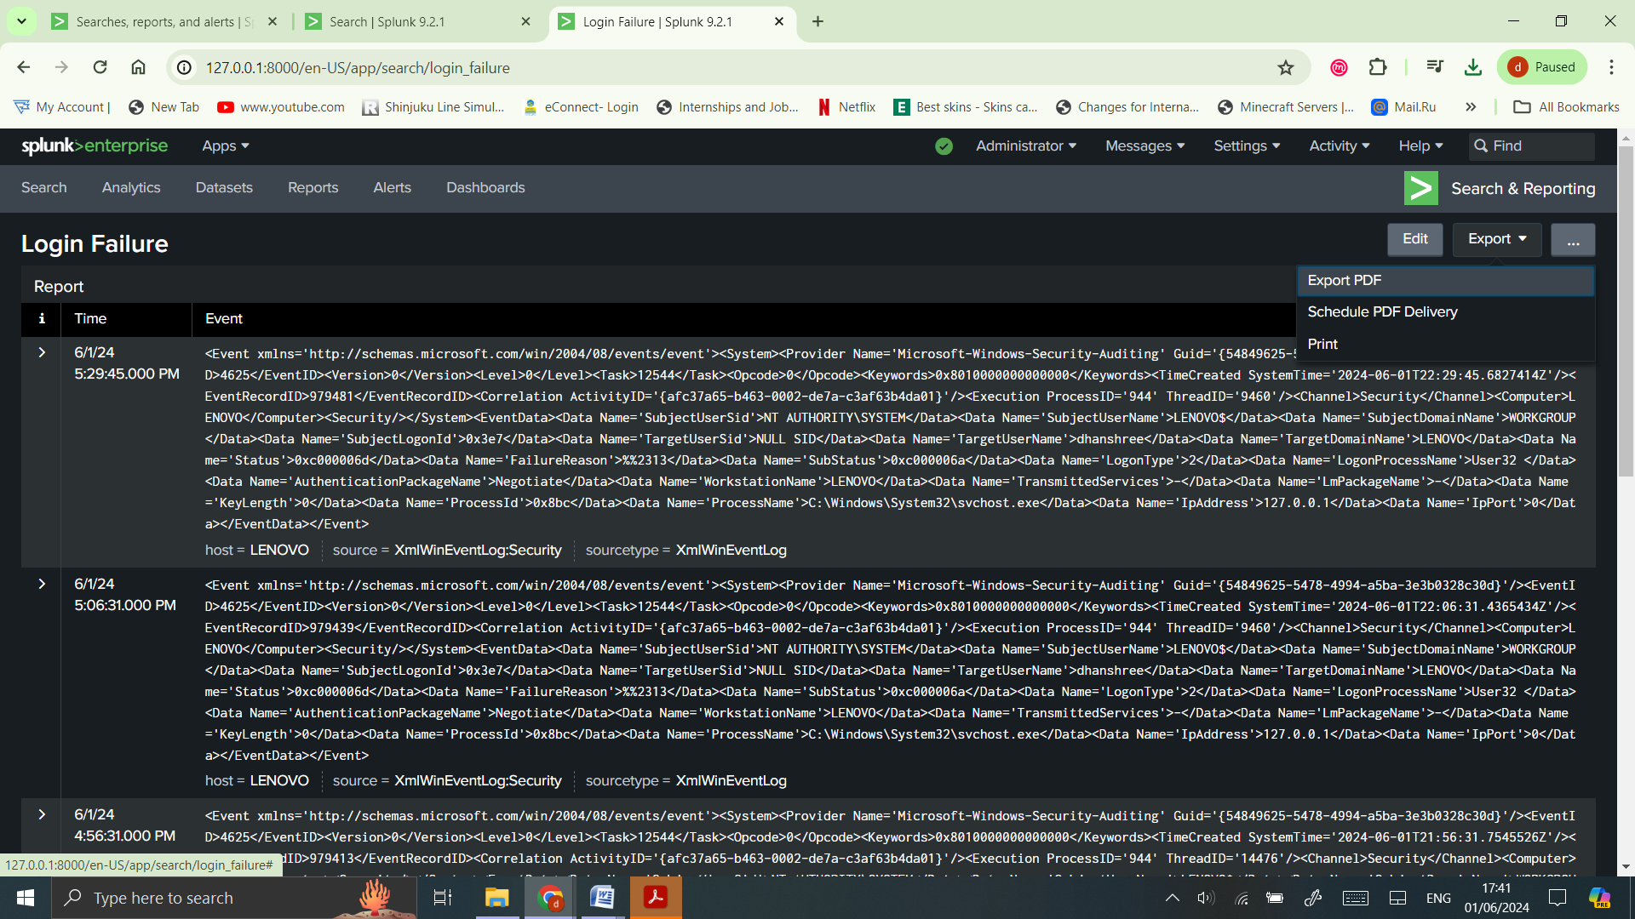

**Exported Report as PDF**

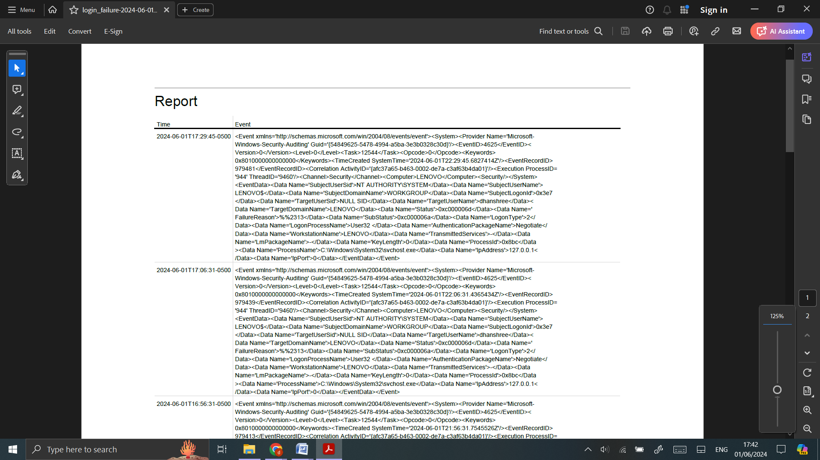

1. **Create Dashboards:**
   * Use the ‘Dashboard’ feature to create visual representations of your data.
   * Add panels to display metrics such as login attempts, suspicious activities, system performance, etc.

**String:**index="main" sourcetype=XmlWinEventLog source="XmlWinEventLog:Security" EventID=4625

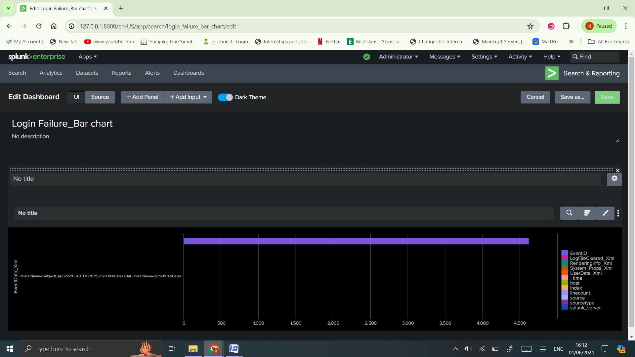**Query:** index="main"